**Titanic Dataset Analysis**

**The Objective of the Study –** Exploratory Data analysis to determine the survival rate on the Titanic using 3 hypotheses; for this study we consider, Age, Sex, and P-Class.

**Dataset:**

* Dataset has 891 passengers, ranging from 314 females to 577 males. Age ranging from 0.42 to 80years based on available data, 177 missing data.
* P-Class has a complete dataset without any missing values, ranging from 1 – for upper class, 2 – for middle class, and 3 for lower class.

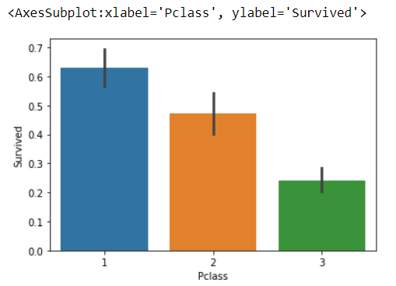

**Analysis and Findings:**

* **P-Class** – survival rate is associated with the

P-class as seen in the bar-chart. Those in

First class had a higher survival rate than those

in 3(economy)

* **Age & Sex** – comparing age & sex to the survival

rate, it can be deduced that

* + women stood a higher survival rate than men
  + highest age to survive for men was in the range of 0.4 – 5yrs, whilst for females, it ranged between 0.4 – 25. Even females beyond 25 had a higher survival rate in comparison to their mail counterparts.

deduced that highest survival rate for

